**Project Edulead**

**USER MANUAL**

**Infrastructure & Asset Maintenance**



**Sustainable Outreach and Universal Leadership Limited**

#### 

**VERSION HISTORY**

|  |  |  |  |  |
| --- | --- | --- | --- | --- |
| **Date** | **Version No.** | **Created By** | **Updated Section** | **Updated By** |
| 10-10-2023 | Version 0.1 | Priytesh Shah |  |  |
|  |  |  |  |  |

**Content**

General Procedures 3

1. Land 13

2. Buildings 13

3. Floor 14

4. Building Type room 15

5. Building Room 16

6. Assets 17

7. Asset Maintenance Team 21

8. Asset Maintenance 21

9. Asset Maintenance Log 23

10. Asset Repair 23

**General Procedures**

**General Procedures for a Save Screen**

**Create of New document**

1. Login in to the system
2. Go the required workspace, If user have more workspace

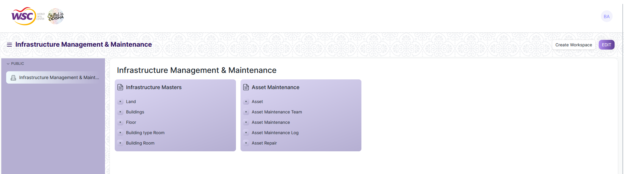

1. Go to the required screen.
2. Click on the ***“+Add Screen Name”*** button in the right corner of the screen.

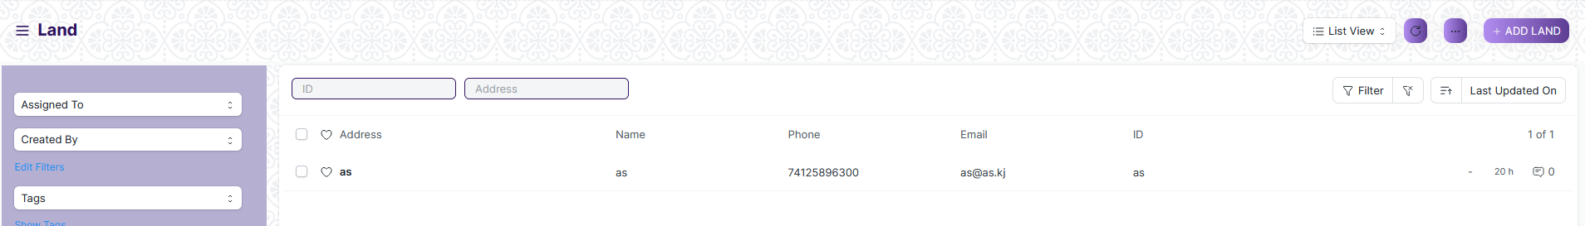

(Example : For addition in the new Land form , click +Add Land button).

1. Enter the required data.
2. Click on “***Save”*.**
3. After saving , the record will be visible in the List View of the screen.



(Example : List view of saved Land)

**Note :** The process of creation can only be carried out by User who have necessary permission.Kindly refer to the Screen wise permission section in the document.

**View a Saved Document**

1. Log in to the system.
2. Go to the required workspace
3. Go to the required screen.
4. Click on the required document from the list view of the screen.



(Example : View of “as” Document of Land Screen)

1. View the clicked document.

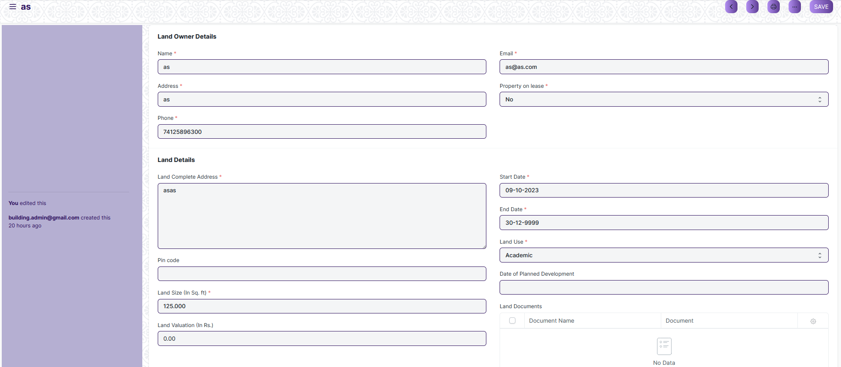

(Example : View of the “as” Land)

**Note :** The process of view can only be carried out by user who have necessary permission.Kindly refer to the Screen wise permission section in the document.

**Delete a Saved Document**

1. Log in to the system
2. Go to the required workspace
3. Go to the required screen.
4. Click on the required document from the list view of the screen.
5. Click on the 3 dots in the right corner of the screen.
6. Click on *“****Delete”*.**

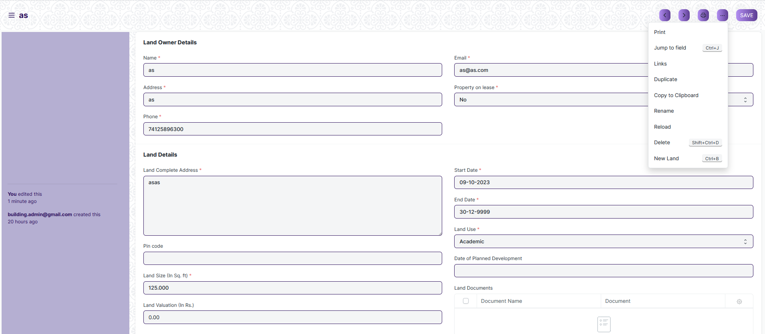

(Example : Deletion of “as” document of Land)

1. Click yes if you want to delete the selected document.

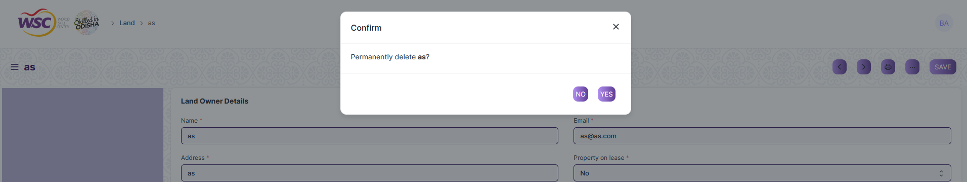

(Example : Clicking Yes to Delete permanently the document)

**Note :** The process of deletion can only be carried out by user who have necessary permission.Kindly refer to the Screen wise permission section in the document.

**Rename a Saved Document**

1. Login to the screen.
2. Go to the required workspace
3. Go to the required screen.
4. Click on the required document from the list view of the screen.
5. Click on the 3 dots in the right corner of the screen.
6. Click on *“****RENAME”*** .



1. Click on *“****Rename”*** button to rename the document.

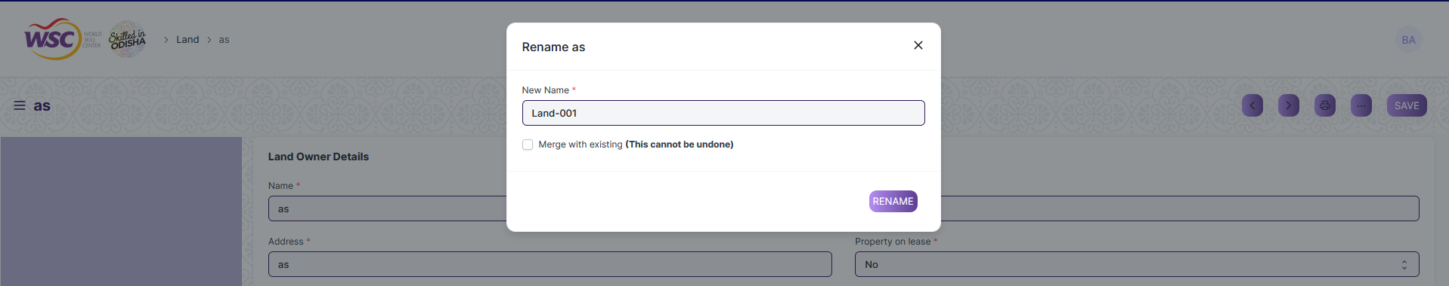

**Note :** The process of deletion can only be carried out by user who have necessary permission.Kindly refer to the Screen wise permission section in the document.

**Print a Saved Document type**

1. Login to the system
2. Go to the required workspace
3. Go to the required screen.
4. Click on a saved document in the screen.
5. Click on the print button present in the right corner of the screen.

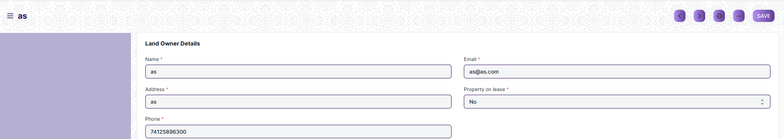

1. A new screen will open.
2. Click on the print button to Print the document.

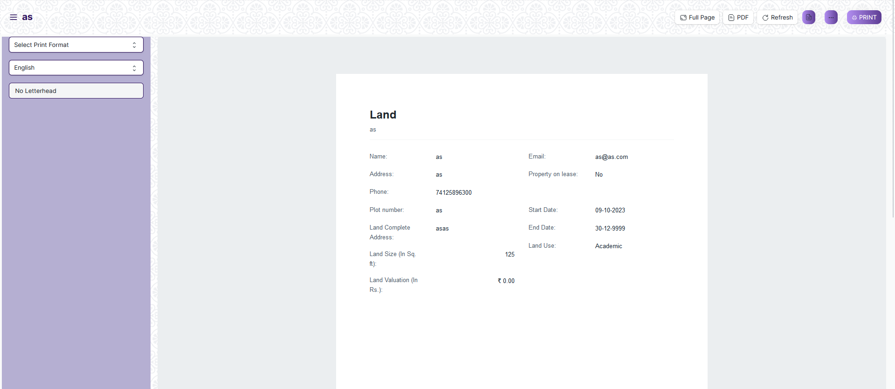

1. To download the employment type as PDF , click on the PDF button .



**Note :** The process of printing can only be carried out by user who have the necessary permission.

**View the saved document in different format.**

1. Login to the system
2. Go to the required workspace
3. Go to the required screen.
4. Click on the List View Button in the screen.

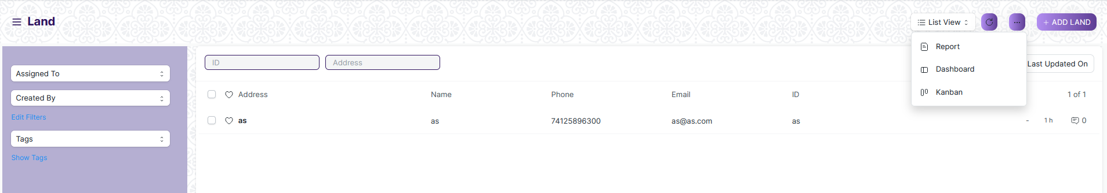

1. Select the appropriate view type that you want.

**Note :** The List view button can only be showed to the user who have necessary permission.

**View the saved documents by applying filters.**

1. Login to the screen.
2. Go to the required workspace.
3. Go to the required screen.
4. Click on the ***“Filter”***.

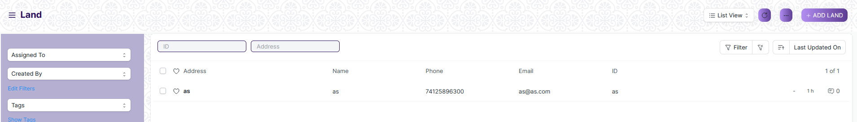

1. Select the field of the document based on which you wish to filter the records. All the fields in a form will be selectable in this list.

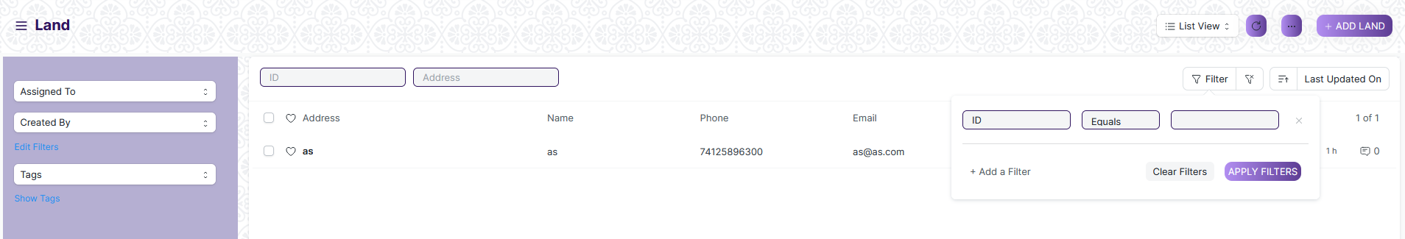

**Based On :** For the field, you will be required to put a value of the field. In the 'based on' field.

**Criteria :** You can define criteria based on which the system will search the document.The different conditions on which the filters are based are: Equals, Not Equal, Like, Not Like, In, Not In, =,>,< etc.

**Value :** Here, you will be required to enter the value for which you are running the document search.

**Some Examples of Viewing the documents in the list view after applying filters.**

Filter on Item Group screen where Is Group Equals to Yes. After clicking the Apply Filter button, all the filtered document will show in the screen.

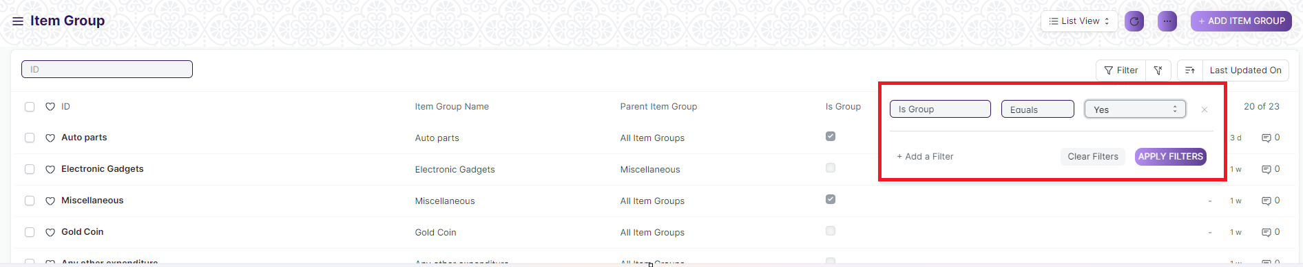

Filter on Item Group Screen where, the Item Group Name starts with ‘A’.

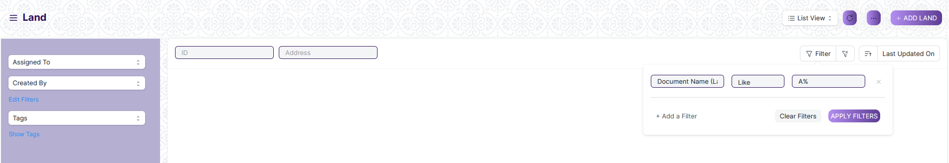

You can also apply multiple filters at a time. To remove a specific filter, just click on 'x' sign on it. To add another filter Click on the +Add a Filter button.

**Example of Multiple filter .**

Applying filter in Land screen , where the Item Group Name starts with ‘A’. and ID equals as.

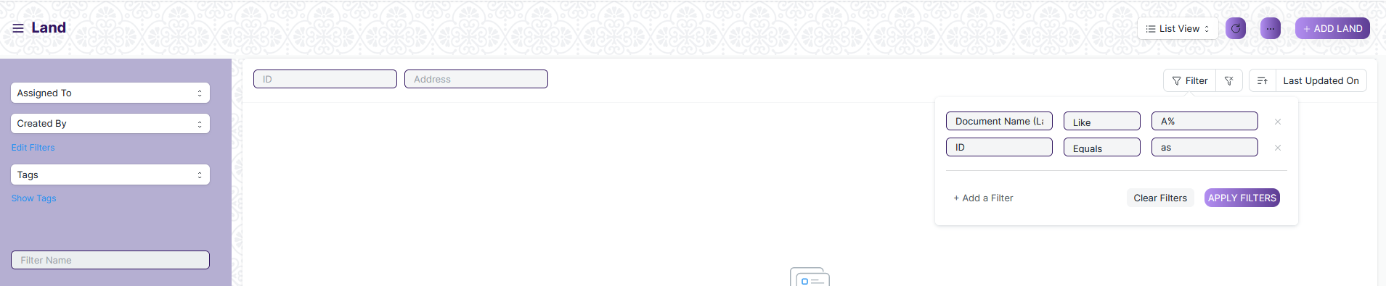

**Default Filters**

There are some filters present out of the box for the views which can be used for filtering the search results.

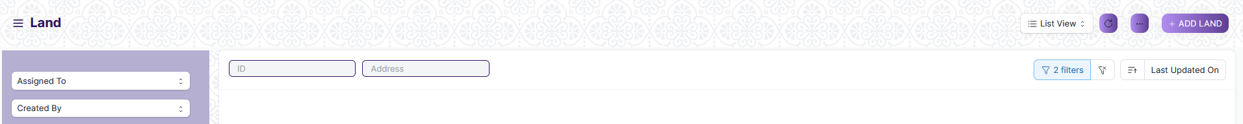

**Note :** The Filter Option can only be showed to the User who have necessary permission.

**General Procedure for a Submittable Screen**

**Create of New document**

1. Login in to the system
2. Go the required workspace
3. Go to the required screen.
4. Click on the ***“+Add Screen Name”*** button in the right corner of the screen.

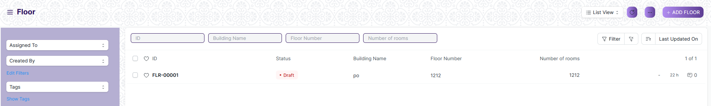

(Example : For addition in the new Floor , click +Add Floor button).

1. Enter the required information in the document.
2. Once you are finished entering the information , click the ***“Save”*** button.
3. After saving it , a submit button will appear.

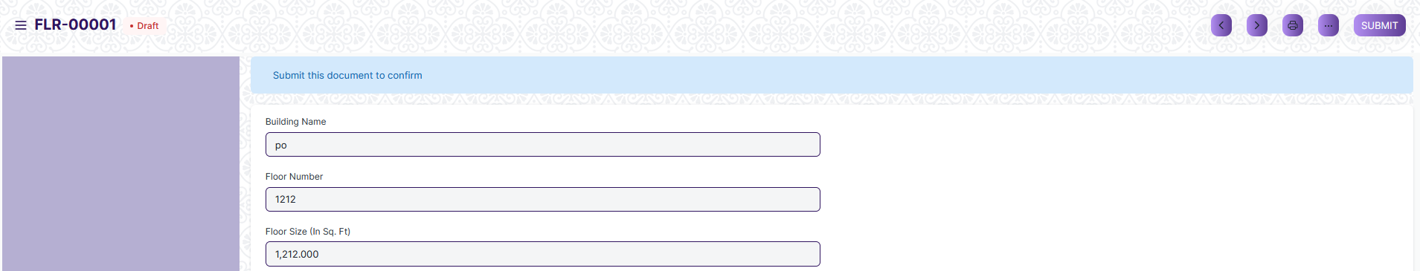

1. Click on the **“Submit”** button.
2. A confirmation dialog box will appear . Click the Yes button to submit the document.

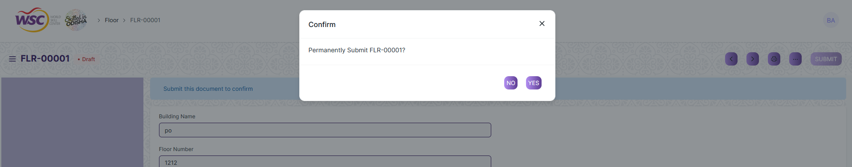

1. After submitting , the record will be visible in the List View of the screen.

**Note :** The process of creation can only be carried out by user who have necessary permission.Kindly refer to the Screen wise permission section in the document.

**Cancel a Submitted Document**

1. Log in to the system.
2. Go to the required workspace
3. Go to the required screen.
4. Click on the required document from the list view of the screen.
5. Click the ***“Cancel”*** Button .

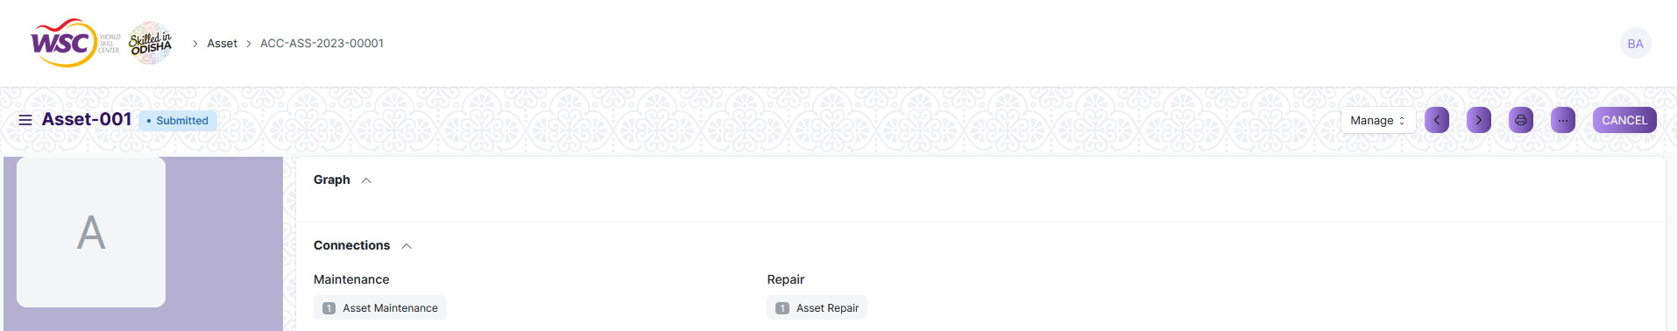

1. A confirmation dialog box will appear . Click the Yes button to cancel the document.

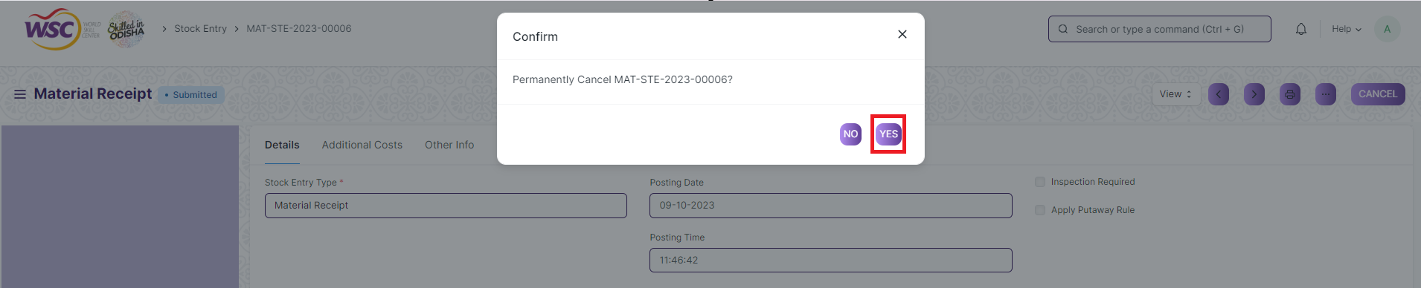

**Note :** The process of cancellation can only be carried out by user who have necessary permission. Kindly refer to the Screen wise permission section in the document.

**Amend a Submittable Document**

1. Log in to the system.
2. Go to the required workspace
3. Go to the required screen.
4. Click on the required document from the list view of the screen.
5. After cancellation of the document , an Amend button will appear on the screen.

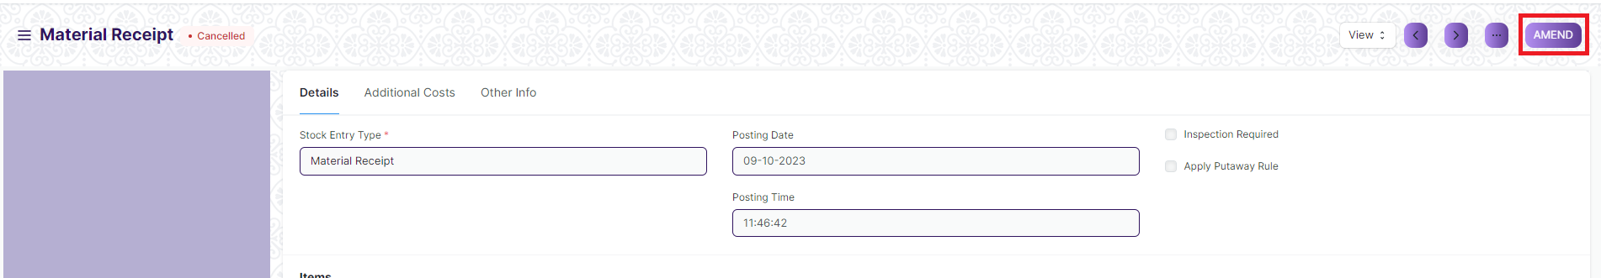

1. Click the “***Amend”*** button.
2. A new document will be created with the same information as the original document .



1. You can now make changes to the document as needed.

**Note :** The process of Amend can only be carried out by user who have necessary permission.Kindly refer to the Screen wise permission section in the document.

**Action Menu on a document.**

The three dots menu, located in the right corner of a document in a Screen , offers a range of actions and options to manage and interact with the document.

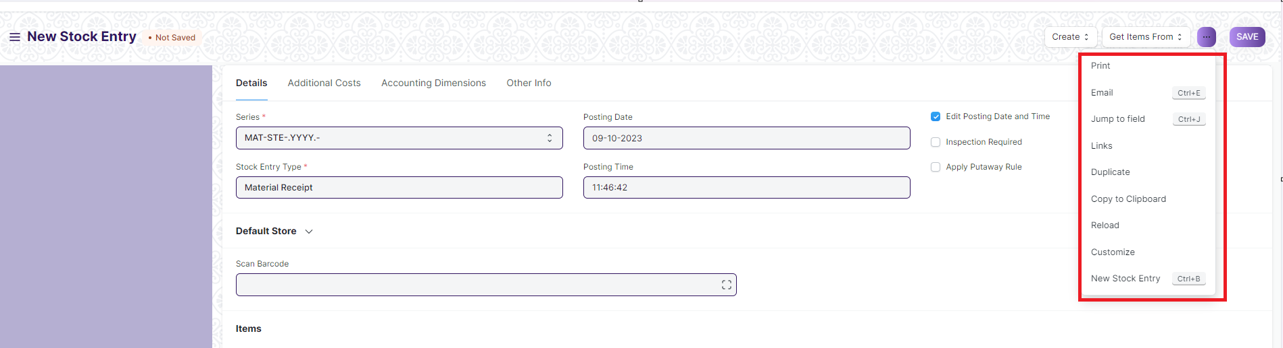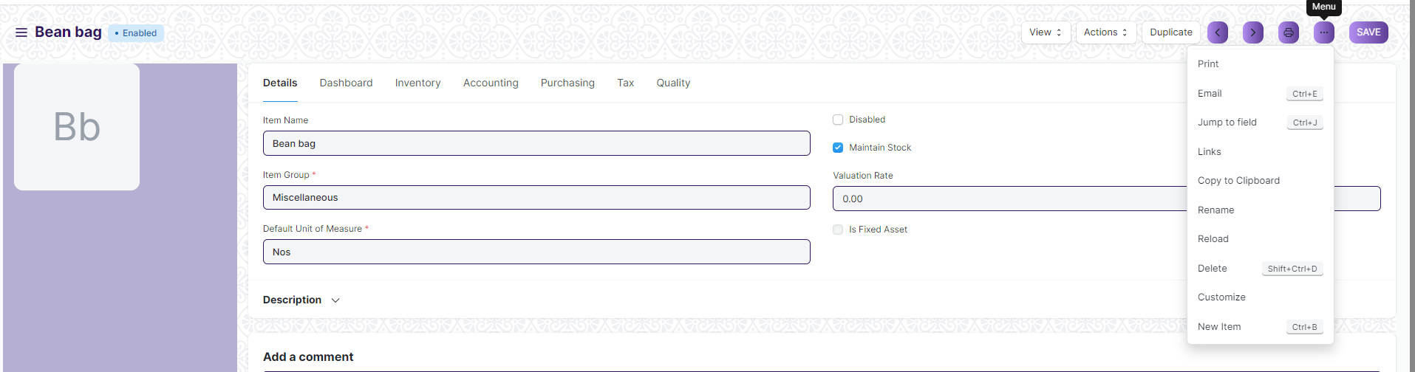

The functionalities available in the three dots menu are given below .

**Print :** Print Enables you to generate a printable version of the document ., which you can save as a PDF or send to a printer.

**Email :** Click on Email allows you to send the document as an attachment via email to specified recipients.

**Duplicate :** Create a new document with the same information as the current one.

**Delete :** Permanently remove the document.

**Cancel :** Cancel the submitted document.

**Submit :** Submit the document . If the document is submittable.

**Links :** This Option displays a list of document that are linked to the current document. You can navigate these linked documents from here.

**Jump to field :** You can directly go the required field by clicking this option and giving appropriate field name.

**Copy to Clipboard :** By clicking this option you can copy the content of the document .

**Rename :** By clicking the Rename option you can Rename the document.

**Note :** These options will be visible to User who have necessary permission.

### Land

This is a master screen which holds data regarding the land. Land here is in reference to the plot of land on which the building is built. The Land Master shall have attachment buttons for Allotment Letter and other documents.

To access the Land list, go to:

Home > Infrastructure Management & Maintenance > Infrastructure Masters > Land

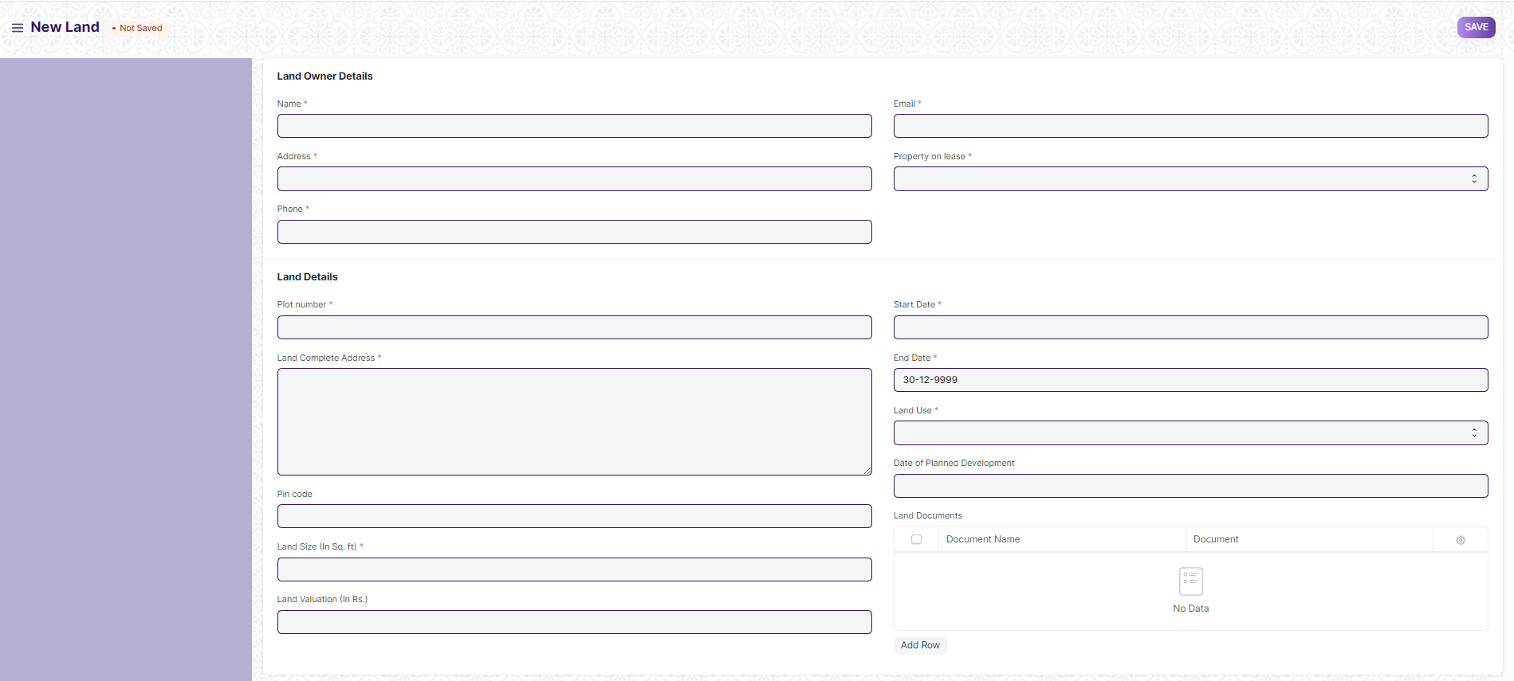

#### 1.1 How to create Land

1. Go to Land list, click on New
2. Enter details Like Land Owner details like Name, Address, Phone, Email, Property on lease, Land details like Plot number, Land complete address, Pincode, land size, land valuation, start date, end date Land use, Date of planned development, land documents
3. Save the form

### Buildings

This is a master screen for buildings. All the building information shall be stored here including documents like Building Letter(Records of right and Building design), Fire Approval, Electrical Inspection, etc. The buildings can be residential, academic or both. The actions on this screen can be performed by the administrator only.

To access the Buildings, go to:

Home > Infrastructure Management & Maintenance > Infrastructure Masters > Buildings

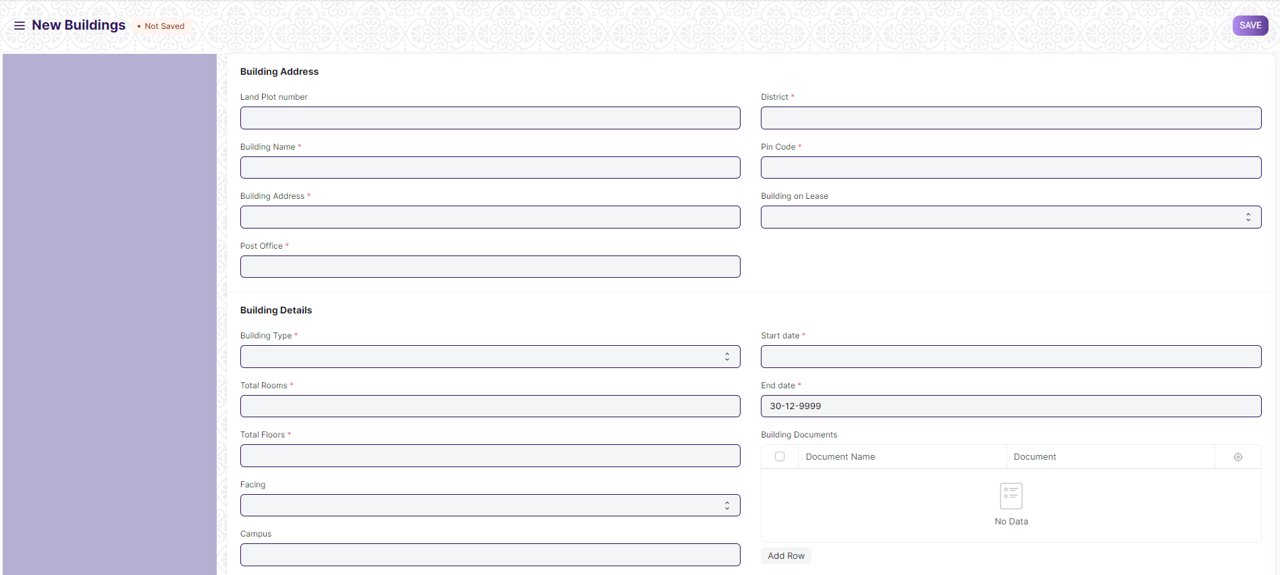

#### 2.1 Prerequisites

Before create Buildings, it is advised that you create the following first:

* Land
* District

#### 2.2 How to create an Buildings

1. Go to the Buildings list, click on new
2. Select a Land
3. On the basis of Land, Land Address will auto-fetched
4. Enter the Building name, Post Office, select District based on which State will be auto fetched
5. Enter Pin code, Building on Lease, Building details like Building type, Total rooms, Total Floors, Facing, Campus, Start date, End date, Building documents, etc
6. Click on Save

### Floor

Floor Master Screen is a screen which will help the user to manage and track the layout of a building's floors and associated fixed assets. It provides an interface that allows users to view floor plans, assign fixed assets to specific locations, and record important maintenance information.

To access the Floor, go to:

Home > Infrastructure Management & Maintenance > Infrastructure Masters > Floor

#### 3.1 Prerequisites

Before create Floor, it is advised that you create the following first:

* Building
* Floor Incharge
* Floor Asset

#### 3.2 How to create Floor

1. Go to Floor list and Click on New
2. Select Building name, enter Floor number, Floor size, Number of rooms, Floor Incharge
3. Attach Floor Plan
4. Enter Floor Assets like Item code, Item name, Location, Asset name, Custodian. Floor documents like Document name, Document
5. Click on Save

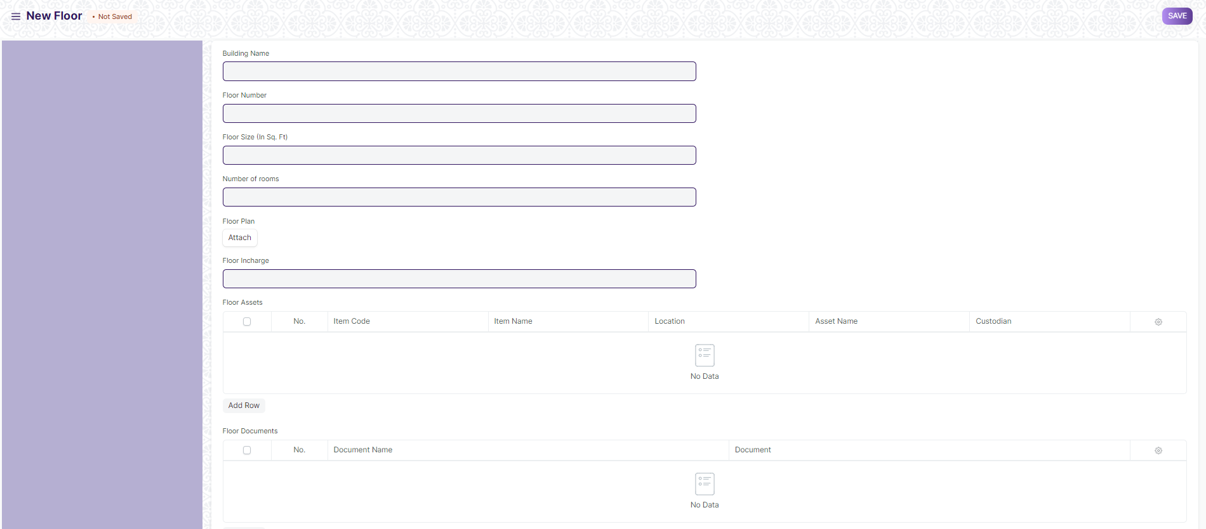

1. **Building Type room**

This screen helps define the type of the room, for example if it is a classroom or residential or conference hall. The operations on this screen can be performed by the Administrator only.

To access the Building Type Room, go to:

Home > Infrastructure Management & Maintenance > Infrastructure Masters > Building Type room

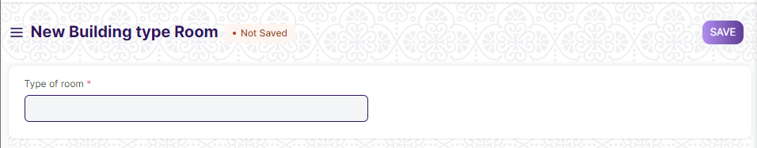

#### 4.1 How to create **Building Type room**

1. Enter Type of room.
2. Click on Save.
3. **Building Room**

This is a master screen, in which we shall be storing the building’s room details and classifying the rooms. This screen also help us assign a number to the residence ( For e.g, Residence number).

To access the Building Room, go to:

Home > Infrastructure Management & Maintenance > Infrastructure Masters > Building Room

#### 5.1 Prerequisites

Before create Floor, it is advised that you create the following first:

* Building

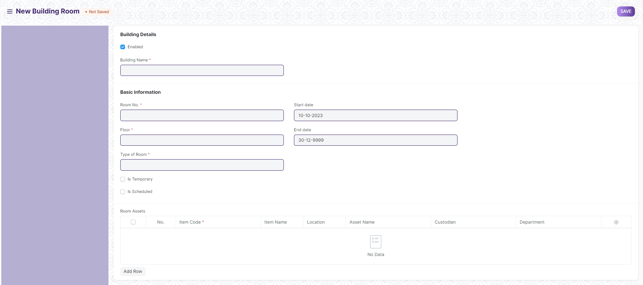

#### 5.2 How to create Building room

1. Go to the Building room list and click on New.
2. Select Building name, based on which Building type, Building address, Buildings Land Plot number, District, State, Pin code will be auto fetched.
3. Enter Room No., Floor, Type of room, Start date, end date
4. Select If temporary if that room is not permanently and Is Scheduled if the room is a permanent room
5. If Is Scheduled is ticked, enter Seating Capacity and Room Name
6. Enter Room Assets like Item Code, Item Name, Location, Asset Name, Custodian, Department
7. Click on Save.

#### 5.3 **Features**

If Is Scheduled is ticked, and you save the Building room The room as entered here will be created as the Room name and seating capacity that we enter here

1. ****Assets****

**An Asset is any valuable Item owned by a Company.**

Furniture, computers, mobile phones, printers, cars, manufacturing equipment are examples of assets. Generally, an asset is a tangible item that is located on the company premises or is carried by an employee. In some cases, an asset could be an intangible item.

An asset's useful life spans across multiple years and hence its economic value is spread over corresponding years from the accounting perspective. If you buy a printer for $300 and it is expected to be useful for three years, from the accounting perspective $100 is recorded as the expense for three years each instead of all the $300 in the first year. Most countries have rules for such calculations.

The Asset record is the heart of asset management module. All the transactions related to an Asset like purchasing, depreciation, maintenance, movement, scrapping, sales will be recorded against the Asset record.

To access the Assets, go to:

Home > Infrastructure Management & Maintenance >Asset Maintenance > Asset

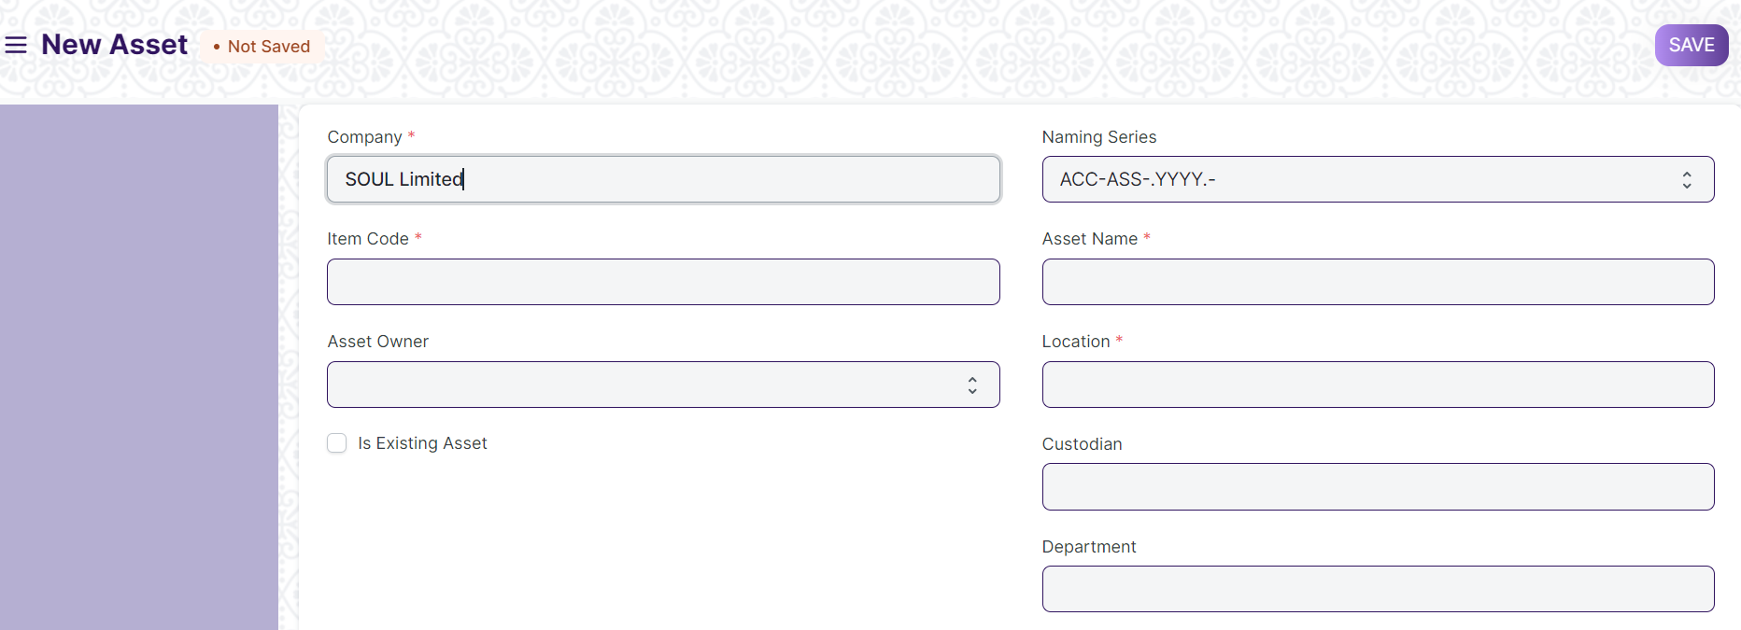

#### 6.1 Prerequisites

* [Item](https://docs.erpnext.com/docs/v13/user/manual/en/stock/item) with 'Is Fixed Asset' enabled.
* [Asset Category](https://docs.erpnext.com/docs/v13/user/manual/en/asset/asset-category)

#### 6.2 How to create an Asset

An Item representing the asset should be created. The **'Maintain Stock'** should be **unchecked** and **'Is Fixed Asset'** must be **checked**.

##### **6.2.1 Auto creation of assets**

You can automatically create assets on submission of Purchase Receipt by enabling **'Auto Create Assets on Purchase'** in Item.

If you have enabled auto asset creation for the item representing an asset, you will have to provide the asset location while submitting the Purchase Receipt.

A message confirming the creation of assets is displayed on submission of Purchase Receipt.

##### **6.2.2 Manual creation of assets**

If you would like to create assets manually, create an Item with 'Is Fixed Asset' enabled and leave 'Auto Create Assets on Purchase' unchecked . On submission of a Purchase Receipt/Purchase Invoice with that Item a message is shown indicating that you need to create assets manually.

Follow below steps to create assets manually.

1. Go to the Assets list, click on New.
2. Enter a name for the asset.
3. Select the Item Code. Item Name and Asset Category will be fetched automatically.
4. Select the Asset Owner, i.e. Company, Supplier, or Customer.
5. Select the Company/Supplier/Customer.
6. Select the Purchase Receipt/Purchase Invoice. Purchase Date and Gross Purchase Amount will be fetched automatically.
7. Select a Location. Eg: Mumbai Office. This will be fetched automatically if specified in Purchase Receipt items table
8. Set Available-for-use Date. The depreciation will be calculated starting from this date.
9. Click on Save and Submit.

Please note you need create **one asset record for each asset you have bought**. If you have bought five computers and have created just one Purchase Receipt with quantity set to five then you will have to create five asset records manually.

##### **6.2.3 Importing existing assets**

You will have to add details of all the assets your company has purchased previously along with depreciation details of each asset.

For an existing asset, you can create the asset record directly by checking **"Is Existing Asset"** checkbox and provide below details.

* Gross Purchase Amount
* Purchase Date
* Available-for-use Date
* Opening Accumulated Depreciation: The accumulated depreciation amount which has already been booked for an existing asset.
* Number of Depreciation's Booked: Number of depreciation entries already booked.

Based on these details the schedule for depreciation of remaining amount will be created automatically.

##### **6.2.4 Additional options when creating an Asset**

1. ****Custodian****: The employee who will carry the asset.
2. ****Department****: The department of the Custodian.
3. ****Next Depreciation Date****: Mention the next depreciation date, even if it is the first one. If the asset is an existing one and depreciation has already been completed, leave it blank.
4. ****Calculate Depreciation****: Enable this checkbox to calculate depreciation of Assets.
5. ****Allow Monthly Depreciation****: Enable this checkbox to distribute depreciation amount of an asset into 12 months of the year. Depreciation entries will be made every month on the date provided as Depreciation Start Date. For example, if Available for Use date is 22nd Nov 2019 and depreciation Start Date is 31st March 2020, first depreciation will be done on 30th Nov 2019 second on 31st Dec 2019 and so on. Amount will be distributed based on days left until next depreciation.

#### **6.3. Features**

##### **6.3.1 Depreciation**

* ****Frequency of Depreciation (Months)****: The number of months between depreciation's.
* ****Total Number of Depreciation's****: The total number of depreciation's during the useful life of the Asset. In case of existing assets which are partially depreciated, mention the number of pending depreciation's. For example, if you set frequency as 12 months and no. of depreciation's as 3, 1 depreciation will be booked every 12 months for 3 years.
* ****Depreciation Method****: These are three methods used for depreciation :
  + ****Straight Line****: This method spreads the cost of the fixed asset evenly over its useful life.
  + ****Double Declining Method****: An accelerated method of depreciation, it results in higher depreciation expense in the earlier years of ownership.
  + ****Written Down Value****: In this method, the depreciation percentage is fixed but it is applied on the current value of the asset which we get after each depreciation.
* ****Depreciation Start Date****: The date from which booking of depreciation will be started.
* ****Expected Value After Useful Life****: Useful Life is the time period over in which the company expects that the asset will be productive. After that period, either the asset is scrapped or sold. In case it is sold, mention the estimated value here. This value is also known as Salvage Value, Scrap Value, or Residual Value.
* ****Rate of Depreciation****: This will be calculated based on the amount entered in expected value after useful life.

##### **6.3.2 Depreciation Schedule**

On booking depreciation's against this Asset, the Depreciation Schedule section will be visible. This table has columns for Finance Book, Schedule Date, Depreciation Amount, Amount Depreciated, and Journal Entry.

##### **6.3.3 Insurance Details**

If Insurance has been taken for the Asset you're recording, you can store the following Insurance details:

* Policy number
* Insurer
* Insured value
* Insurance Start Date
* Insurance End Date
* Comprehensive Insurance

##### **6.3.4 Accounting Entries**

On submission of an asset, "Capital Work in Progress" account will be credited and the asset account related to the asset will be debited. Submission is only possible after entering "Available-to-use Date". If "Available-to-use Date" is a future date, then accounting entry will be booked automatically on that date via the scheduler.

##### **6.3.5 Maintenance**

Ticking on Maintenance Required allows recording Asset Maintenance entries for this Asset.

##### **6.3.6 After Submitting**

Once you create an Asset, you'll see options to transfer, scrap, or sell the asset. From the Make button, you can adjust its value and make a depreciation entry.

1. ****Asset Maintenance Team****

**The Asset Maintenance Team is responsible for carrying out maintenance activities on the Asset.**

The maintenance activities can be cleaning, polishing, servicing, or any other activity required to maintain the Asset in good condition.

To access the Asset Maintenance Team, go to:

Home > Infrastructure Management & Maintenance >Asset Maintenance > Asset Maintenance Team

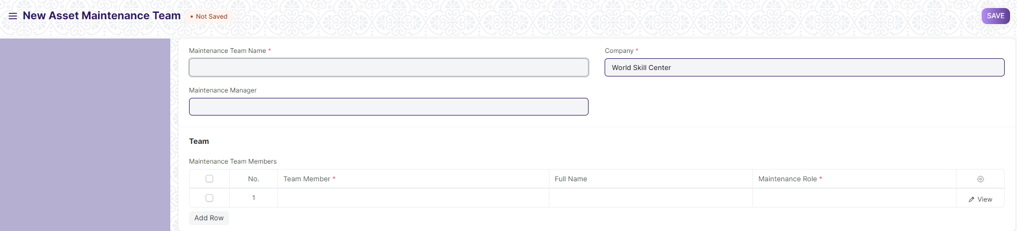

#### **7.1 Prerequisites**

* Employee
* Asset

#### **7.2 How to create an Asset Maintenance Team**

1. Go to the Asset Maintenance Team list, click on New.
2. Enter a name for the team.
3. Select a manager for the team.
4. In the Maintenance Team Members table, add the team members and select their maintenance [roles](https://docs.erpnext.com/docs/v13/user/manual/en/setting-up/users-and-permissions/role-and-role-profile).
5. Save.
6. ****Asset Maintenance****

**Asset Maintenance refers to any activity done on Assets to maintain their performance or condition.**

To track the details of individual maintenance/calibration tasks for an asset by date, the person responsible for the maintenance, and future maintenance due date.

To perform Asset Maintenance:

1. Enable 'Maintenance Required' from the Asset master.
2. Create an Asset Maintenance Team.
3. Create the Asset Maintenance.
4. An Asset Maintenance Log is created.
5. Create Asset Repair Log.

To access the Asset Maintenance, go to:

Home > Infrastructure Management & Maintenance >Asset Maintenance > Asset Maintenance

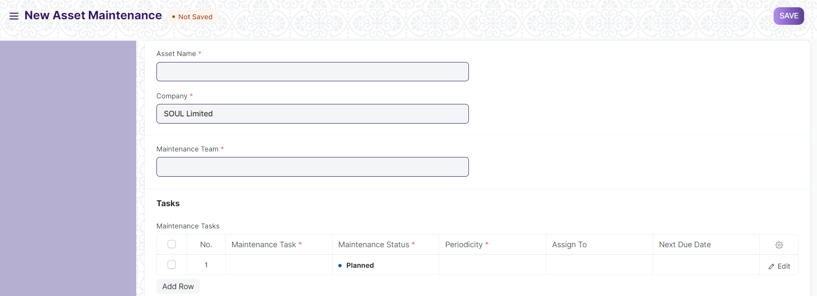

#### **8.1 Prerequisites**

* Asset with ‘Maintenance Required’ Checked
* Asset Maintenance Team

#### **8.2. How to create Asset Maintenance**

For each asset, create an Asset Maintenance record listing all the associated maintenance tasks, maintenance type (Preventive Maintenance or Calibration), periodicity, assign to and start and end date of maintenance

1. Go to the Asset Maintenance list, click on New.
2. Select the Asset.
3. Select the Asset Maintenance Team.
4. Add Maintenance Tasks in the table.
5. Set the Maintenance Status whether 'Planned', 'Overdue', or 'Canceled'.
6. Select a periodicity for which the task needs to be carried out. The next due date will be calculated.
7. Click on Save.
8. After saving, you can assign the task to a user.
9. If the Item is serialized, the Serial Number can be entered.

#### **8.3 Features**

##### **8.3.1 Maintenance Tasks**

* ****Maintenance Type****: Whether this is a 'Preventive' maintenance activity or 'Calibration' to restore accurate functioning.
* ****Start and End Date****: Set the start date and end date when the maintenance is supposed to begin and end.
* ****Last Completion Date****: If the maintenance was not carried out on or before the scheduled date, the actual date of maintenance can be recorded here.

1. ****Asset Maintenance Log****

**Asset Maintenance Log logs the tasks carried out in an Asset Maintenance.**

For each task in Asset Maintenance, Asset Maintenance Log is **auto created** to keep track of the upcoming maintenance's. It will have a status, completion date and actions performed. Based on completion date here, next due date is calculated automatically and new Asset Maintenance Log is created.

To access the Asset Maintenance Log, go to:

Home > Infrastructure Management & Maintenance >Asset Maintenance > Asset Maintenance Log

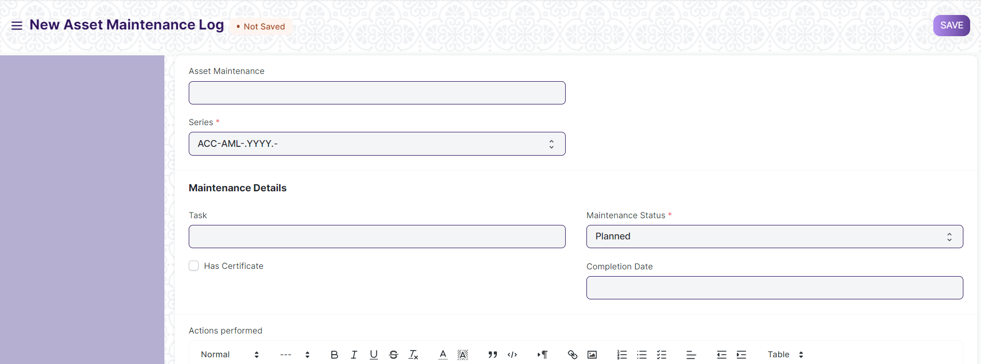

#### **9.1 Prerequisites**

* Asset Maintenance

#### **9.2 Options in Asset Maintenance Log**

A Draft of the Asset Maintenance Log is created as scheduled in the Asset Maintenance form. In order to submit an Asset Maintenance Log, the Asset Maintenance status has to either 'Completed' or 'Canceled'.

* The status of the Asset Maintenance Log can be 'Planned', 'Completed', 'Canceled', or 'Overdue'.
* Additional notes can be added in the Actions performed section to describe the activity in detail.

1. ****Asset Repair****

**Asset Repair refers to any activity carried to repair a broken Asset to restore full functionality.**

You can also maintain the records of Repair/Failures of Assets which are not listed in Asset Maintenance.

To access the Asset Repair, go to:

Home > Infrastructure Management & Maintenance >Asset Maintenance > Asset Repair

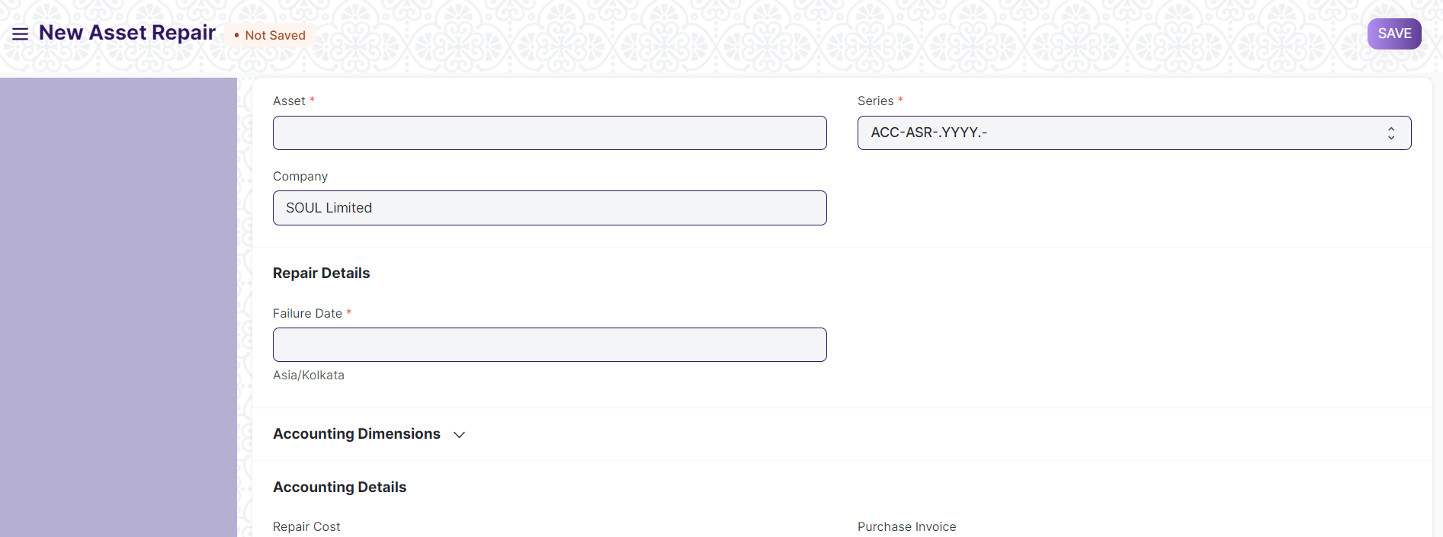

#### **10.1 Prerequisites**

* Asset

#### **10.2 How to create an Asset Repair**

1. Go to the Asset Repair list, click on New.
2. Select the Asset.
3. Select the Failure Date.
4. Enter the Repair Cost.
5. Click on Save.
6. Change the Repair Status from 'Pending' to 'Completed', or 'Canceled'.
7. Select a Purchase Invoice if Repair Cost is greater than zero.
8. Click on Save and Submit.

##### **10.2.1 Additional options when creating an Asset Repair**

* ****Capitalize Repair Cost****: If checked, the Repair Cost will be added to the Asset's value. This could also allow you to increase the Asset's life.
* ****Increase In Asset Life(Months)****: The number of months by which the Asset's life might be extended by the repair can be added here. This will modify the Depreciation Schedule of the Asset. This field will only be visible if Capitalize Repair Cost is checked.
* ****Stock Consumed During Repair****: Checking this will allow you to make a note of all the Stock Items consumed during the repair.
* ****Store****: The Store from which the Stock Items consumed during the repair were taken should be entered here, if Stock Consumed During Repair is checked.
* ****Stock Items****: Entering Stock Items consumed during the repair here will create a Stock Entry record of type Material Issue for them, thereby decreasing their quantity. GL Entries will also be created for each Item in the table. This table will only be visible if Stock Consumed During Repair is checked. In case of Serialized Items, the Item row can be expanded to reveal the Add Serial No button.
* ****Error Description****: A detailed description of the problem can be entered here.
* ****Actions Performed****: A sequence of actions performed to carry out the repair can be noted down here.

#### **10.3 Features**

##### **10.3.1 Accounting Dimensions**

Accounting Dimensions let you tag transactions based on a specific Territory, Branch, Customer, etc. This helps in viewing accounting statements separately based on the selected dimension(s).

##### **10.3.2 Purchase Invoice**

A Purchase Invoice can be linked with the Asset Repair, to account for any Items that need to be purchased to carry out the repair or the repair service offered.

##### **10.3.3 Total Repair Cost**

If Stock Consumed During Repair is checked, the Total Repair Cost will be computed based on the value of the consumed Stock Items and the Repair Cost entered.